Network Topologies
 | Advantages | Disadvantages
Bus Topology  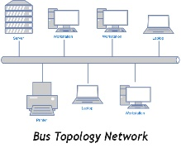 | -Less expensive as only one wire is used for the terminal.  -One node failure does not affect the others.  -Suited for temporary networks.  -Easy to connect nodes to the network. | -No security.  -Limited wire length.  -The network fails if the main cable is broken.  -Network becomes slower as more cables are added.
Ring Topology  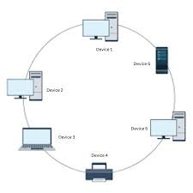 | -Better performance than bus topology.  -All nodes have equal access.  -Relatively cheap to install and expand. | -No security.  -One point failure affects the whole network.  -Is difficult to troubleshoot.  -More nodes= less performance.
Star Topology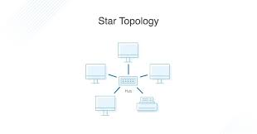 | -Easy to design and implement.  -Allows scalability.  -Centralized administration. | - Failure in hub or switch affects entire network.  -Overloading switch or hub causes bottlenecks.  -More expensive due to the switch or hub.
Mesh Topology  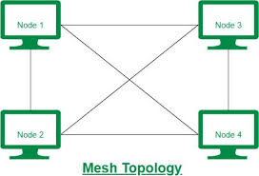 | -It is fault tolerant.  -It is reliable. | -Issues when broadcasting.  -It is expensive due to a lot of wires.  -Impractical for larger networks.
Tree Topology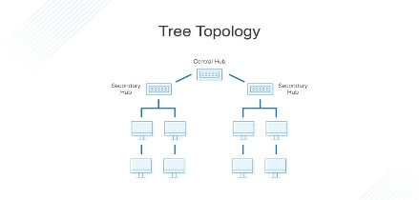 | -High scalability.  -Centralized administration.  -Fault isolation. | -Cabling is complex.  -It is expensive.  -If the central backbone fails the entire network is affected.

References
Effenberger, S., 2025. Tree topology: structure, benefits and challenges at a glance. [Online]
Available at: https://www.docusnap.com/en/it-documentation/tree-topology
[Accessed 21 January 2026].
Neso Academy, 2020. Network Topology. [Online]
Available at: https://youtu.be/uSKdjjw5zow?si=J7iS8oPLwCFYKJAp
[Accessed 21 January 2026].

